Tugas mingguan ke-11
Nama : Silfiana Dwi Nabiilah
NIM : 221344028
Kelas : 2A TNK
Mata Kuliah : Elektronika Digital Lanjutan
Dosen : Bapak Ferry Satria, BSEE., M.T.
Ibu Rahmawati Hasanah. S.ST., M.T.

- Rangkaian Pembangkit Pulsa
- Diagram state
- Table State
Des | Ps |  |  | Ns
Des | Q2 | Q1 | Q0 | Q2 | Q1 | Q0
0 | 0 | 0 | 0 | 0 | 1 | 1
3 | 0 | 1 | 1 | 1 | 0 | 1
5 | 1 | 0 | 1 | 0 | 0 | 1
1 | 0 | 0 | 1 | 1 | 0 | 0
4 | 1 | 0 | 0 | 0 | 1 | 0
2 | 0 | 1 | 0 | 0 | 0 | 0
- Timing Diagram
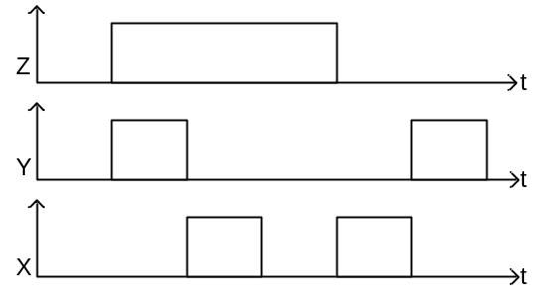

- Rangkaian
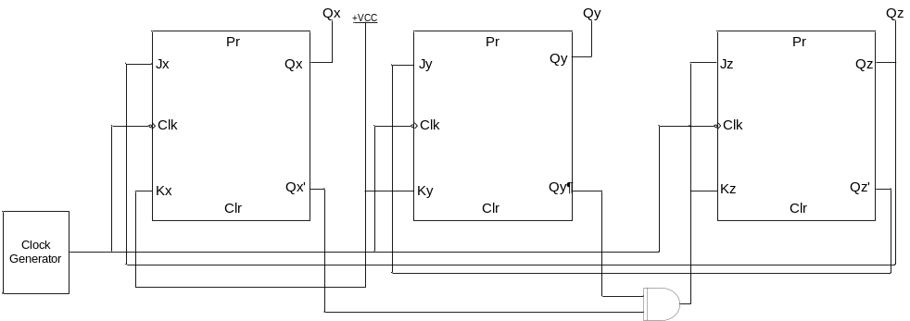
- Rangkaian Pendeteksi Urutan Input (Sequence Detector)
- State Diagram Mealy (OL)
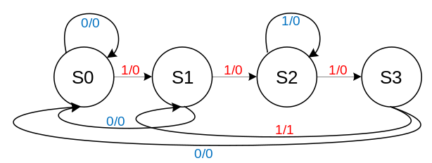
- State Table Mealy OL
PS | Ns, Z
PS | X = 0 | X = 1
S0 | S0, 0 | S1, 0
S1 | S0, 0 | S2, 0
S2 | S3, 0 | S2, 0
S3 | S0, 0 | S1, 1
- State Assignment Table :
PS | Ns, Z
PS | X = 0 | X = 1
00 | 00, 0 | 01, 0
01 | 00, 0 | 11, 0
11 | 10, 0 | 11, 0
10 | 00, 0 | 01, 1

- Persamaan K-maps
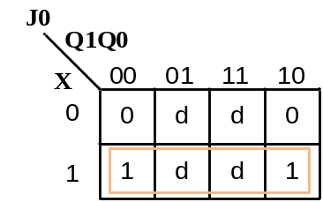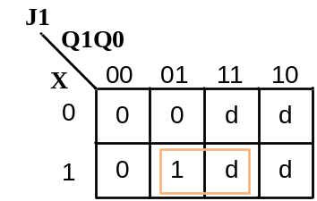
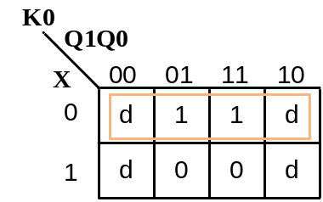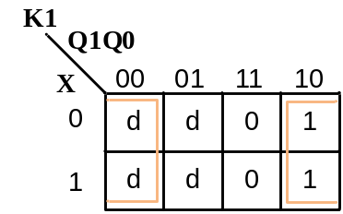
- Persamaan
J0 : X
J1 : X$Q0$
K0 :$\overline{X}$
K1 : $\overline{Q0}$
- Rangkaian
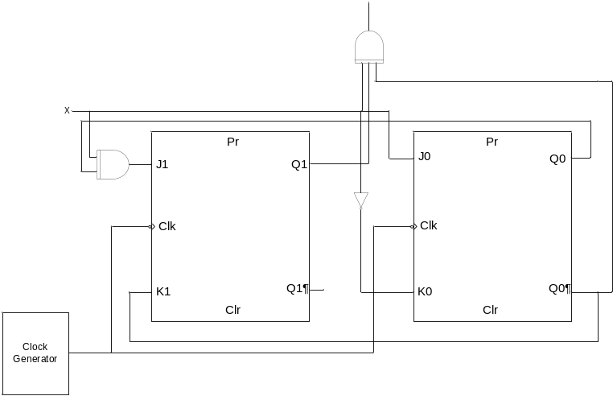
- State Diagram Mealy (NOL)
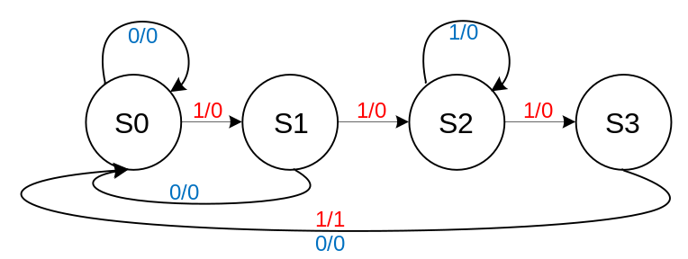

- State Table Mealy OL
PS | Ns, Z
PS | X = 0 | X = 1
S0 | S0, 0 | S1, 0
S1 | S0, 0 | S2, 0
S2 | S3, 0 | S2, 0
S3 | S0, 0 | S0, 1
- State Assignment Table :
PS | Ns, Z
PS | X = 0 | X = 1
00 | 00, 0 | 01, 0
01 | 00, 0 | 11, 0
11 | 10, 0 | 11, 0
10 | 00, 0 | 00, 1
- Persamaan K-maps
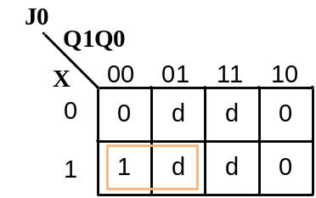
- Persamaan
J0 : X $\overline{Q0}$
J1 : X$Q0$
K0 :$\overline{X}$
K1 : $\overline{Q0}$
- Rangkaian
